**6. Practical exercise. PLANE of the CLASS**

***Goal: to apply all knowledge from previous exercises.***

Task – draw the plane of the class.

1. Arrange the limits and Dimension style.

Command: **limits**

Reset Model space limits (10-fold reduction):

Specify lower left corner or [ON/OFF] <0.0000,0.0000>:

Specify upper right corner <420.0000,297.0000>: 42,29.7

Command: **zoom**

Specify corner of window, enter a scale factor (nX or nXP), or[All/Center/Dynamic/Extents/Previous/Scale/Window/Object] <real time>: a

Regenerating model.

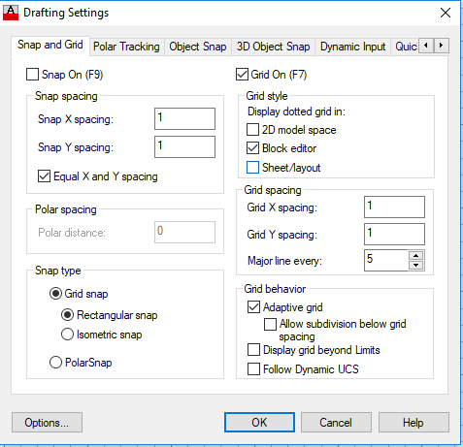

1. Create the layers: Dimensions, Technique, Cable.

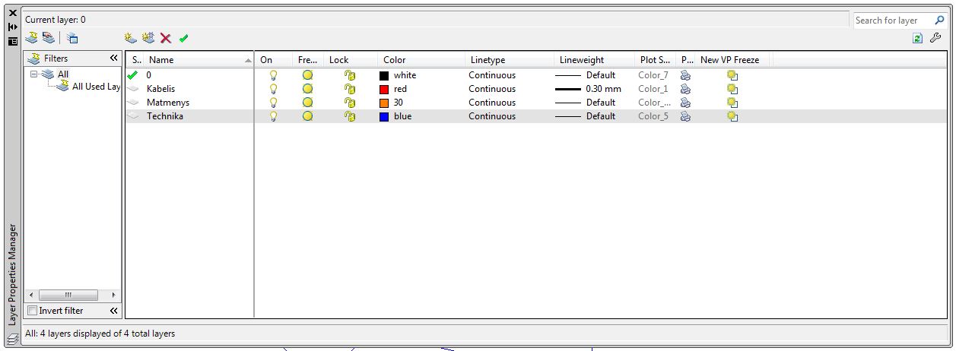

1. Draw the plane.
2. Use command **UTILITIES – AREA**. Measure Area and Perimeter.

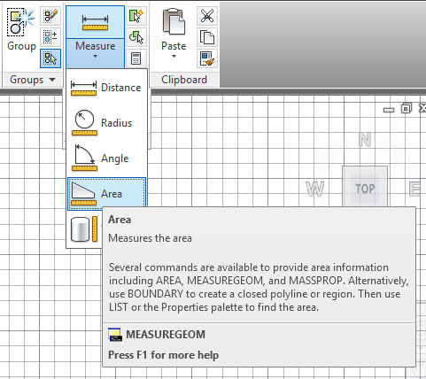

1. Use command **Modify🡺Lengthen** to calculate the length of cabel. Recommendation: use Polyline for Cabel. Write the informatikon about the length of Cabel and Area and Perimeter.

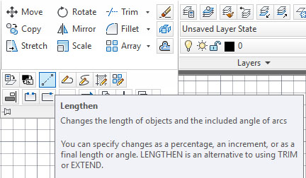

1. For Hach a walls use **Draw🡺Hach**:



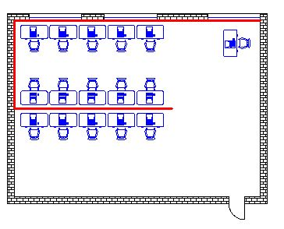

1. Use blocks from **DESIGN CENTER** (CTRL2) to plase the technique.

To change size of Blocks use **SCALE.**

**CTRL2.**

**Program Files – Autodesk – AutoCAD2013 – Sample – en-us –**

**Design Centre – Home Space.**

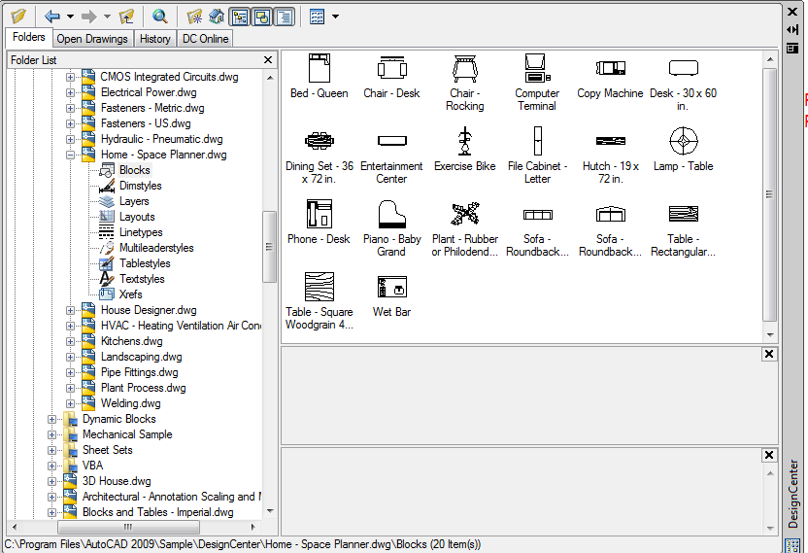

1. **Add Dimensions.**

Create new DimensionsStyle „Plane“.

In FIT card change scale for dimension features (0.1).

In PRIMARY UNITS label – write SUFFIX - m.

In SYMBOLS and ARROWS label – change Arrowheads to ARCHITECTURAL TICK.

